**Understanding how SSIS deals with sensitive data when deployed**

By default, a project is created with EncryptSensitiveWithUserKey protection level

**Test 1**

Create a new project with the protection level of DontSaveSensitive

Create a package called WindowsAuthenticated where the ole db connection is windows authenticated.

When I deploy it says it is changing the protection level…

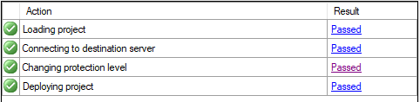

Has it really changed it? And if so what to?

I think it is EncryptSensitiveWithUserKey. Does it matter for this package? No because there is no sensitive data. Lets test this by running it from the Agent using a proxy that doesn’t have the correct windows authenticated rights.

**Test 2**

Create a new project with EncryptSensitiveWithUserKey protection level.

Create a package that doesn’t have a parameter and is encrypting the password with a user key.

Once deployed, I expect it to work if I run it, but not if the proxy runs it.

Okay, so it does run when the proxy runs it. And also when I log in as a different user. So, once deployed, the password is saved with the package and encrypted but, presumably, not with a user key.

If I uncheck the Save my password box then I would expect it to not run once deployed

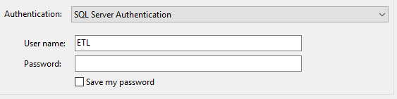

But it did run. That’s because it did save the password. Must be cached somewhere.

Interesting if I run the same package in the project DontSaveSensitive then it won’t run even if I do check the Save my password box. My conclusion at the moment is that box doesn’t do anything.

**Test 3**

In the DontSaveSensitive project, created a project that stores the password in a package parameter. Use the parameter in an expression for the Password property of the connection.

This works if the parameter is not marked as Sensitive. If it is then it doesn’t work. Why? Seems that you are only supposed to flip it to Sensitive just before deploying it.

Tested this and it still didn’t work. The value is lost when it is deployed. Same thing when the parameter is at project level. So, current conclusions is the flag a parameter as sensitive doesn’t do anything.

**Test 4**

Hold the password in an environment variable which is shown as sensitive. This works. Now I understand the point of the Sensitive flag of the parameter. It is to show that it is sensitive and will have to be supplied by a sensitive environment variable.